Chapter 5
Development of Psychiatric COVID-19 CHATBOT using Deep Learning
Dr. Nivedita Bhirud¹* Subhash Tatale² Dr. Priyanka Jain³ Archis Kulkarni⁴ Mayuresh Panchpor⁵ N. K. Jain⁶

¹ Assistant Professor, Computer Engineering, VIIT, Pune, India nivedita.bhirud@viit.ac.in *
²Assistant Professor, Computer Engineering, VIIT, Pune, India
³Associate Director, Artificial Intelligence Group, CDAC, Delhi, India
^{4,5}Student, Computer Engineering, VIIT, Pune, India
⁶Senior Director, Artificial Intelligence Group, CDAC, Delhi, India
Abstract. According to the Indian Psychiatric Society, the number of people in India suffering from mental illness has increased by 20% during the pandemic and lockdown. This situation necessitates the use of technology, such as a chatbot. In this paper, the authors proposed a PSYchiatric COvid-19 (PSYCO-19) chatbot which provides mental assistance. The scope of the proposed work covers multidisciplinary areas like Psychiatric Analysis, Mental Health, Communication system, Machine Learning (ML), Natural Language Processing (NLP), Deep Learning (DL), and Sentiment Analysis (SA).
The proposed chatbot has a well-designed architecture with a structured knowledge engine to provide an intuitive interface. The design consists of three components with a good balance of cohesion and articulation through medical knowledge and conversational dialogue. It is backed by a bank of structured information resources connected to COrona VIrus Disease 19 (COVID-19). The chatbot also offers mental health counseling and self-assessment exams for mental illnesses, in addition to corona virus information.
The novelty of the proposed work is to provide an interface to interact with the virtual avatar in a rich environment supported by voice and language capabilities. It advises the user to consult a medical practitioner to determine whether they are affected with COVID-19 and provide them with recommendations. Along with providing a psychiatric assessment to the end-user and conversation with interactive virtual avatars, the proposed chatbot can understand texts in the English language, with a training accuracy of 66 % of the proposed deep learning model.
Keywords. Psychiatric Analysis, Mental Health, Machine Learning, Natural Language Processing, ChatBot, Sentiment Analysis, Deep Learning, COVID-19. .
- Introduction
In 2019-2020, the COrona Virus Disease (COVID-19) began and spread throughout the world. The most prevalent symptoms are a self-reported fever, fatigue, dry cough, myalgia, and dyspnea. Unusual symptoms include sputum production, headache, hemoptysis, and diarrhea [1]. The majority of people recover from this illness without the need for medical intervention. However, it has been found that those over the age of 65 and those with medical issues such as cardiovascular disease, diabetes, chronic lung disease, and cancer are more prone to develop significant illnesses that lead to death. Because this virus can survive on surfaces for long periods, it has moved across the world more swiftly. As a result, there have been widespread government shutdowns, which have resulted in a sharp decrease in social connections.
People were obliged to spend most of their time alone in their homes. The mental health consequences of this condition are poorly understood. On the one hand, such drastic changes in daily routines may be harmful to mental health. However, since the entire population was affected, it may not be viewed negatively. The short and long-term effects of this crisis on mental health are unknown. The acute mental health impacts of large-scale epidemics across communities have been studied earlier. Fear of infection, job loss, and financial stress are likely to produce psychological distress in the general population during the acute period [2]. Children may be more prone to mental health illnesses due to the higher risk of infection and the stress caused by parental loss or separation [3]. According to the current survey, more than two-fifths of the population suffers from common mental ailments due to the lockdown and the ongoing COVID-19 epidemic [4].
To provide psychiatric support in mental health treatment, the authors proposed a system using cutting-edge technological approaches. This approach intends to help COVID-19 and people's mental health from the comfort of their own homes. Chatbot technology does this by understanding the user's language and responding to their questions. Bhirud, N. et al. [5] provided NLU and ML-based chatbot systems for effective healthcare support. This chatbot responds to questions on mental health and COVID-19. The proposed system also includes a preliminary COVID-19 test. The user can check for COVID-19 symptoms and their intensity by answering specific questions. The proposed system employs a user-friendly interface based on mobile technology to reach the broadest possible audience. Worry, anxiety, and tension have been reported as a result of a sudden and near-constant flood of news about an outbreak on social media, as well as rumors and unauthenticated material [6]. The dissemination of accurate information about the coronavirus aids in the reduction of misinformation and confusion regarding the disease. It also explains how to prevent the virus from spreading in the home and public places. It is necessary to provide information on the symptoms of COVID-19 and their severity. A quick self-assessment test will also be provided so that users can assess themselves in the comfort of their own homes. As previously stated, pandemics and lockdowns may have negative impact on people's mental health, leading to issues such as sadness and anxiety. As a result, the authors also aim at providing mental health assistance. People can use brief self-assessment mental tests to examine their mental health. These tests aid in determining the degree of mental illnesses that people may be experiencing. There shall also be an arrangement to discuss the user's thoughts and mental problems. Psychiatric guidance is provided to the user.
The Covid 19 test covers primary Covid-19 symptom check. The chatbot module provides appropriate answers to English or Hindi input question relating to Covid-19 and mental health. Depending on the user's input it is offered a depression test to assess their severity of depression.
The paper is organized as Section 1.2 discusses works related to our proposed system, Section 1.3 describes the logical flow of the sub-components of the system. It also talks in-depth regarding the working of all the components and provides details about the internal working of the chatbot. Section 1.4 summarizes all of the findings and limitations of all of the components. It consists of tables regarding the results of chatbot and training parameters and a graph for training the latest model. Section 1.5 concludes the entire project and discusses future possibilities for improving the system's effectiveness.
- Related Work
With the rise of COVID-19 cases, various people and institutions came up with numerous technological solutions for various pandemic situations by providing COVID-19 related information and primary diagnosis using chatbots and Artificial Intelligence. Here, the authors provide a detailed survey on related work covering technology, language, features, and usability, mainly in the healthcare domain.
Chaturvedi A. et al. [7] use one or more parameters as search criteria to find free-form natural language inquiries from users for blood and related services like a list of blood banks, live bloodstock, blood donation camps, and many more. Frequently Asked Questions (FAQs) or data-driven queries, including location-based services, are examples of possible queries. Gabrielli S. et al. [8] aims to conduct a proof-of-concept evaluation of Atena, a psychoeducational chatbot that promotes good stress and anxiety coping among university students. It is created with Java Script and distributed on the Telegram client. It analyses the user using a predefined set of questions. Ferreira et al. [9] developed a Brazilian Chatbot Assistant. In the Brazilian towns of Belo Horizonte and Divinopolis, Ana's initial focus will be on supporting Brazilian Portuguese-speaking patients seeking information on the ailment and screening suspect cases. It was made with the BLiP platform and distributed through WhatsApp.
Much work has been reported specific to mental health support as well. Cameron G. et al. [10] is designed a system to provide mental health counseling for people. It asks users a series of pre-determined questions and scores their mental health based on their responses. Ouerhani N. et al. [11] is an intelligent pervasive chatbot for emergency case assistance based on Cloud Computing. It helps victims or incident witnesses to avoid degradation of the subject's condition and maintain his/her physical integrity until help arrives, potentially increasing the victim's survivability chances dramatically. It parses the user's input using Natural Language Processing and provides a mobile application to engage. Ni L. et al. [12] designed a chatbot to automate the patient intake phase. The chatbot engages with a patient by conducting interviews, comprehending their primary problems in natural language, and delivering findings to professionals for additional investigation. The service includes a patient-facing mobile app, a diagnostic tool, and a reporting tool. Chung K. et al. [13] proposed a chatbot-based mobile health service for delivering immediate care for accidental and chronic diseases. It leverages data collected daily from users to deliver information on chronic diseases and critical healthcare. Grové C. et al. [14] proposed a chatbot that revolves around the well-being of younger generations persons. Many young people struggle to cope with scholastic stress, despair, anxiety, and the lack of proper support for these pressures. The author proposed the chatbot approach to solve these issues. Its dataset was developed using real-life interviews, and a model was built on top of it. It makes use of a variety of techniques.
Some researchers published research articles related to Human Interaction System. Park et al. [15] suggested a chatbot for stress recognition and treatment using a guideline-based technique and NLP to address various psychological strains of people via questionnaire. Google's dialog flow was utilized for training and structuring the chatbot, and it aided in the creation of the essential dataset as well as the training of the chatbot. Facebook messenger was used to communicate with the users. It collects data from users by text input or by allowing them to select from a list of predefined options. Amato F. et al. [16] proposed a chatbot to eliminate human involvement in the medical support system. It aids patients in determining the most appropriate illness prevention strategy by seeking a variety of data to facilitate the relevant prevention check-up and final diagnosis. The suggested interaction has been validated in a real-world clinical situation, where the chatbot was used as part of a medical decision to provide helpful advice on various disease preventive options.
Some researchers studied the latest research work related to COVID-19 as well. Judson, T. J.et al. [17] proposed a digital chatbot to screen the staff of the health system during the COVID-19 pandemic. This chatbot is designed to conduct initial screenings of healthcare personnel for symptoms or potential exposures. It features a customized UI that consumers can use to engage with the chatbot and get tested. For evaluation, it employs a collection of questions. Ouerhani N. et al. [18] designed a chatbot to help pre and post-isolation engage with a person to raise his or her understanding of the genuine hazard of this pandemic during and after quarantine. Moreover, utilizing NLP, COVID-Chatbot can identify and deal with pre- and post-shutdown stress and isolation periods. It communicates using a JSON API enabling website as well as the Android interface for the chatbot. Rodsawang C et al. [19] published a report on COVID-19 related information. A crisis report, how to protect oneself from COVID-19, fake news, COVID-19 self-screening, a list of nearby hospitals, the hotline number to call, and report notification are among the seven prompt features. Data from reliable sources were converted into a question-and-answer system during the early phases of development and fed into Google Cloud's dialog flow for NLP. Battineni, G. et al. [20] presented the design of a powerful AI chatbot for the goal of diagnosing patients who have been exposed to nCOV-19 and proposing prompt remedies. Furthermore, by displaying a virtual assistant, the infection severity can be measured and registered doctors can be contacted if symptoms grow critical.
Some general techniques used in the primary research papers are mentioned here. Bharti U.et al. [21] has designed a multilingual chatbot to provide information and advice for chronic patients. Sancheti et al. [22] presented the chatbot system architecture and adaptive self-learning algorithm for providing services in healthcare domain in both English and Hindi languages. It is built on serverless architecture and combines a doctor's services by providing preventive measures, home remedies, interactive counseling sessions, healthcare advice, and symptoms for the most frequent ailments in rural India. Comendador B. E. V. et al. [23] developed a conversational chatbot that prescribes, suggests, and provides information about generic children's drugs. It has a C# interface and database built-in MS Access and uses the NLP algorithm. It was successfully evaluated by professional pediatricians as well as pharmacy students. This chatbot recommends generic drugs after a series of conversations and consultations, including proper dosage, drug reaction, precaution, and prescription indication. A parametric comparative analysis of research papers is mentioned in Table I.
TABLE I
COMPARATIVE ANALYSIS OF RESEARCH PAPERS
Sr. No. | Paper | Services provided | Users | Technology used | Interface provided
1 | SPeCECA [11] | Emergency case assistance | Ordinary citizens | NLP | Mobile application
2 | Towards a chatbot for digital counselling [10] | Mental health assistance | Workplace employees | Uses set of predefined questions | No interface
3 | MANDY [12] | Automate the patient intake phase | Ordinary citizens | NLP | Mobile app for patients, platform for doctors
4 | Chatbot-based healthcare service with a knowledge base for cloud computing [13] | Uses users’ data collected daily to provide information regarding chronic diseases and critical healthcare. | Ordinary citizens | Collects user’s physical information via sensors | Uses android application
5 | A Development of Chatbot for Emotional Stress Recognition and Management using NLP [15] | Stress recognition and treatment | Ordinary citizens | NLP | Facebook Messenger
6 | Chatbots meet eHealth: automatizing healthcare [16] | Eliminate the need for human involvement in the medical support system | Ordinary citizens | NLP | Custom interface called HOLMeS
7 | Smart Ubiquitous Chatbot for COVID-19 Assistance with Deep learning Sentiment Analysis Model[18] | COVID-19 help pre and post isolation | Ordinary citizens | NLP | Mobile application, Web interface
8 | Co-developing a Mental Health and Wellbeing Chatbot With and for Young People [14] | Mental health chatbot aimed at young generation | Young people | Combination of NLP and pre-loaded questions | Mobile interface
9 | Implementation of a digital chatbot to screen health system employees during the COVID-19 pandemic [17] | Primary checkup for healthcare workers | Healthcare workers | Pre-defined questions. | Custom interface
10 | Medbot: Conversational Artificial Intelligence Powered Chatbot for Delivering Tele-Health after COVID-19 [21] | Providing information and advice to chronic patients. | Ordinary citizens | Google Cloud Platform | Mobile platform
11 | Pharmabot: A Pediatric Generic Medicine Consultant Chatbot [23] | Primary healthcare for children | Children | Non-AI based NLP | Custom Interface for C#
12 | Designing a Competent Chatbot to Counter the COVID-19 Pandemic and Empower Risk Communication in an Emergency Response System [19] | Providing information related to COVID-19 | Ordinary Citizens | DialogFlow | Google Cloud Platform
13 | A Hybrid Approach to Develop and Integrate Chatbot in HealthInformatics Systems [7] | Blood bank management and general chatbot for health services | Ordinary citizens and blood bank management system users | NLP | Web based interface
14 | Engagement and Effectiveness of a Healthy-Coping Intervention via Chatbot for University Students During the COVID-19 Pandemic: Mixed Methods Proof-of-Concept Study [8] | Mental health support for University students | University Students | Predefined questions | Telegram
15 | ANA: A Brazilian Chatbot Assistant about COVID-19 [9] | Providing information related to COVID-19 | Ordinary citizens | Intent Entity System | Whatsapp
It is found that there is not a complete end-to-end system with the functionality of assessment tools, an interactive conversational system using deep learning methodology and virtual avatars. It motivated the authors to propose a design that would have extendibility for Indian languages supportive of the local cultural environment.
- Proposed Work
The proposed PSYchiatric COvid-19 (PSYCO-19) chatbot is described in this section. As discussed in previous sections, COVID-19 testing and providing mental assistance to people without physical interaction is essential. Although corona tests and mental assistance are offered at many locations, personal contact and disease transmission are dangerous. Hence, the authors proposed a contactless PSYCO-19 chatbot system. Figure 1 shows the proposed architecture. The architecture is majorly divided into the following components:
1) Server and Psychiatric Data Repository
2) Deep Learning Engine
3) Mental and COVID-19 assistance interface.
These components are explained in the following sections.
    - Server and Psychiatric Data Repository
In this section, the architecture of the proposed system, along with the server and repository, is explained. The client-server architecture is used for optimal communication between the interface and the chatbot server. Mobile devices acting as clients are used as the interfaces; JSON API connects these systems. A computing backend server hosts the chatbot system. The server delegates the chatbot model and the user's request. A trained model is loaded and executed by the chatbot model. Finally, the required data is saved as a CSV file, which acts as the data repository.

    - Deep learning engine
In the most basic terms, a psychiatric chatbot serves as a personal psychiatrist for the user. Human psychiatrists react to moods and emotions of the patient. It helps them get through a difficult time and their thoughts in order. In order to play the role of psychiatrist, the proposed chatbot needs to know the emotional status of the patient. The deep learning engine module works on understanding natural language (user query) and responds in natural language (respond to user query). Therefore, the deep learning engine is broadly divided into two modules; semantic analysis and sequence-to-sequence transformer. The sentiment analysis module is also provided in the deep learning engine to analyze emotions of the user. The working of all modules of the deep learning engine is explained in the following sections.

      - Semantic analysis
This module converts the natural or human-readable language into machine-readable. The user queries that the server receives are written in natural language. These queries are preprocessed to eliminate short forms of popular terms and improve the overall quality of the queries. A tokenizer and a supporting dictionary are used to turn the words in the query into vectors of integers called word vectors. These word vectors are then fed into the model as input.

      - Sequence-to-Sequence transformer
A general Sequence to Sequence (seq2seq) model is a neural network that converts the given input sequence into another sequence. The proposed system uses the sequence-to-sequence transformer to respond to user requests. This transformer takes a sequence of characters as input and generates a sequence based on it. This model is used to solve the problem of sequence generation. In addition, this model employs the concept of attention heads, which allows it to store almost infinite amounts of information.

      - Sentiment analysis
In this module, the user's overall mental state is determined using all the user's inputs to analyze the sentiment. According to the output of this module, feedback is given to the user viz. Positive, Neutral, or Negative. At the end of the conversation of the user with the PSYCO-19 chatbot, the user's total sentiment score is calculated. The user is then asked to appear for a depression assessment based on this sentiment score.
    - Mental and COVID-19 assistance interface
The interface aims to provide easy and smooth interaction with the chatbot without expertise for all the users.

      - Preliminary COVID-19 test
This module allows users to self-evaluate his/her symptoms of coronavirus. The proposed test is a straightforward offline test that allows people to investigate their symptoms in the privacy of their own homes. It is a short questionnaire that asks people about various primary and significant corona symptoms and then delivers test results based on their responses. The answer of the questions should be "yes" or "no." The outcomes are assessed using a linear formula, a solidified version of the output of a machine learning model. This model was created using data from the United States and the United Kingdom [24]. Its outcome is quantitative because it is a mathematical formula, and it estimates the likelihood of the user being contracted with COVID-19. Appropriate inferences are made and supplied based on the range of this likelihood.

      - Chatbot messaging interface
A messaging interface can be used to communicate with a chatbot, and it is designed to resemble most other messaging apps. As a result, the user does not need any special knowledge or skills to use it.

      - Virtual avatar
The virtual avatar is a three-dimensional (3D) human model that allows for more human interaction. The user can ask a question using audio input. The 3D model plays a talking animation after the chatbot creates an answer, and the answer is presented using text-to-speech technology.


Server
Android communication
Psychiatric Data Repository
Mental and COVID-19 assistance system
Preliminary COVID-19 test
Chatbot Communication
Deep Learning Engine
Semantic Analysis
Sequence-to-sequence Transformer

Figure 1. The Proposed Architecture

- Implementation
T In this section, the implementation detail of all of the proposed system is given. For the simplification, modules are categorized into three parts, such as
1) Assessment Modules
2) Deep Learning Engine
3) Server Configuration and Virtual Avatar
    - Assessment modules
The assessment module includes two assessment tests, namely, the preliminary COVID-19 test and the depression test. Both tests are to be taken by the user himself/herself without any medical knowledge requirement, making it easier to estimate the user’s conditions right from their homes. Both tests are explained in the following sections.

      - COVID-19 test
A COVID-19 testing advisory system is one of the add-ons features the authors included in the proposed system. It screens the user for all possible symptoms and then inputs that information into the COVID-19 algorithm. The model is developed to predict if the user is infected with COVID-19. The COVID-19 test consists of six questions, two of which are subjective, and the rest are yes or no questions. These questions are based on the general symptoms of COVID-19. This formula is generated as a final result of a model trained on data generated through surveys based on these questions. The formula is as follows:
Prediction Model = (- 1.32) - (0.01 x age) + (0.44 x gender) + (1.75 x loss of smell and taste) + (0.31 x severe or significant persistent cough) + (0.49 x severe fatigue) + (0.39 x skipped meals)
The coefficients of this formula are derived using a model trained on datasets from the United States and the United Kingdom. The authors utilize a one-dimensional array with the same number of symptoms, i.e., 4 (loss of smell and taste, cough, exhaustion, and lack of appetite), and set all symptoms to 0. During the test, the user must answer questions about symptoms, and if a specific symptom is present, 1 is entered at that index, reflecting the symptom in the array. After answering all of the questions, the formula as mentioned above is used to calculate the likelihood of developing COVID-19. If the probability is less than 0.5 and the array contains no ones, the user is not contracting COVID-19. However, if the probability is less than 0.5 and the number of ones in the array is larger than zero, the user may be experiencing COVID-19 symptoms. Finally, if the probability is more than 0.5, the user has COVID-19 symptoms and should contact a COVID-19 center near his or her home. This feature tackles practically all outliers and produces the best results possible.

      - PHQ-9 assessment
The PRIME-MD [25] mental disorder screening tool has been condensed into one brief questionnaire termed PHQ-9. It is not a depression screening test, but it is used to monitor depression severity. However, it can be utilized to provide a preliminary diagnosis of depression. Each of the nine questions has a score ranging from "0" to "3" on the depression module of PHQ-9. These 4 options to answer these questions are:
1) Not at all
2) Several days
3.) More than half of the days
4) Nearly every day
These options have weightage from 0-3. The score for each question is added. If the final score is:
Less than equals 4 - minimal depression
Less than equals 9 - mild depression
Less than equals 14 - moderate depression
Less than equals 19 - moderately severe depression
Else: severe depression

    - Deep learning engine
The problem involved in chatbot systems is to understand the meaning of the user’s query. As a solution to this problem, the authors propose a deep learning model. The implementation of the module is divided into two parts; chatbot prediction and sentiment analysis. The implementation of both parts is explained in the following sections.

      - Chatbot prediction
A dataset for mental health comprises a series of questions that a user can ask the chatbot during a conversation. The answers to all of these questions came from live question-and-answer sessions between a psychiatrist and a patient. Some questions and answers are gathered from an extensive search on the internet. Figure 2 and Figure 4 show mental health dataset questions and answers and COVID-19dataset questions and answers of English language, respectively, whereas Figure 3 and Figure 4 show mental health dataset questions and answers COVID-19 dataset questions and answers of Hindi language, respectively.
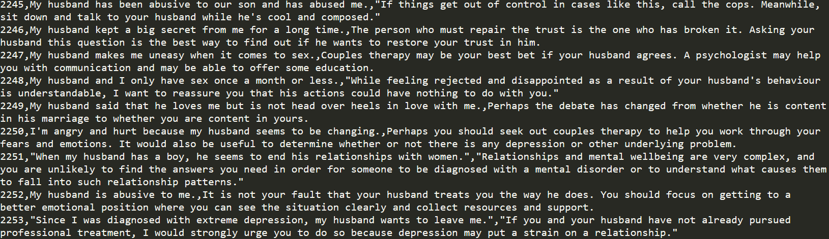
Figure 2. Mental health dataset questions and answers (English)
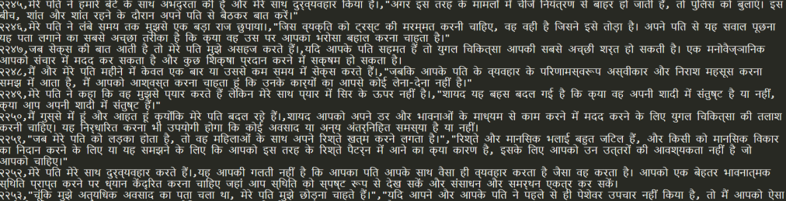
Figure 3. Mental health dataset questions and answers (Hindi)
The COVID-19 dataset, like the psychiatric dataset, contains all COVID-19-related questions and their answers. It provides all COVID-19-related information, allowing the user to clear up any concerns or ambiguities about the disease.
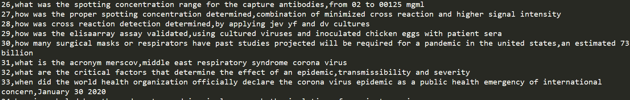
Figure 4. COVID-19dataset questions and answers (English)
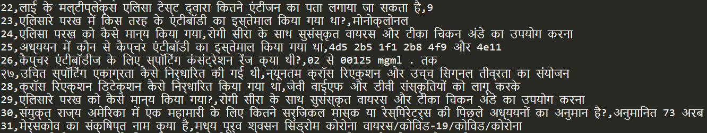
Figure 5. COVID-19 dataset questions and answers (Hindi)
The final dataset is made by combining these two datasets. To increase the vocabulary of the dataset, the authors used paraphrases to construct queries with the same meaning but various sets of words. This dataset was further expanded for the Hindi language by translating the English dataset to Hindi. For prediction chatbot takes Hindi and English input and produces respective output. There are 6907 questions and answers in the final dataset. The CSV format is used to save and access the contents of the dataset. The CSV file containing the dataset is accessed using Python’s Pandas module, and the data is loaded in a Panda’s data frame. Keras and Tensorflow then use this data frame to create the final dataset and model in its format.
Chatbot uses a sequence-to-sequence transformer for answering user queries. This transformer takes a sequence of characters as input and generates another sequence based on it. This model is used to deal with the problem of generating sequences. Transformers comprise 2 parts, namely Encoder and Decoder. The functionality of these two parts is explained in the following sections.

        - Encoder
The encoder module converts the user's input into an abstract numerical representation that is continuous. A multi-head attention module with a padding mask, two dense layers, and a dropout layer make up the encoder layer. Input embedding, positional embedding, and two encoder layers make up each encoder. This encoder converts the input sequence into a fixed-length continuous sequence using padding.

        - Decoder
The decoder builds sequences depending on past output and the encoder's output. Every decoder layer comprises a masked multi-head attention module with a look-ahead mask and padding mask, a masked multi-head attention module with padding mask, and two dense layers followed by dropout. Each decoder includes output embedding, positional encoding, and two decoder layers.
Encoders and decoders use the attention concept, which describes how each input word is related to other words. The attention mechanism in the sequence-to-sequence transformer model examines the input sequence and determines which other sections of the sequence is significant. It takes into account all possible inputs at the same time and assigns weights to them. The transformer's encoder will clean up the input text before encoding it with a fixed-length pad sequence. This encoded sequence is fed into the decoder. The decoder learns the word sequence from the encoder output, applies weights based on significance, and returns the linear layer. This linear layer has a sequence that learns how to embed words based on their importance in the text. The transformer takes the input query, cleans and encodes it again, and then predicts the words, one at a time, based on all the words preceding the current word, and generates the final output.
The encoder-decoder system is followed either by some recurrent layers or convolution layers in many sequence-to-sequence transformers. However, since transformers are primarily concerned with the attention mechanism, the transformer employs a multi-head attention layer. This multi-head layer attention consists of multiple scalar dot products. Query, Key, and Value are the three inputs for scaled dot product attention. The attention weights are calculated using the scaled dot product, and the attention weight defines how much weight should be provided to a specific inquiry. The authors use the following formula to calculate the attention weights:
Attention (Q, K, V) = softmaxk ( (Q * KT) / dk ) * V
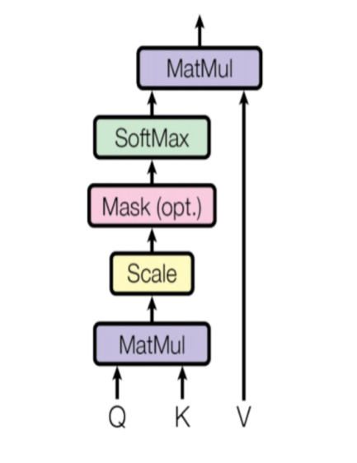
Figure 6. Attention model
The pseudo-code for the Chatbot Prediction is as follows:
- Start.
- Take the user's input.
- Pre-process and tokenize input.
- Make a variable to hold the answer and append the word "START" to it.
- Loop through the code from 1 to the maximum length and then predict the sequence.
- Get the word that is most likely to be the following word using the SoftMax function.
- Decode the sequence that was expected.
- Deliver and display the result on the app
- Stop
Pseudo-code for encoder is as follows:
- Start.
- Retrieve the list of questions and responses from the corpus.
- To build the vocabulary, tokenize the set of questions and responses.
- Set the max length to the answer's maximum length.
- To each answer in the answer list, add “START” and “END” tokens.
- Using the One Hot Encoding Method, create a padding sequence.
- Using the formula, compute the scalar dot product for a padding mask, a look ahead mask, a multi-head attention layer, and a positional encoding technique.
- Get the encoding layers, including multi-head attention with a padding mask, two thick layers, and a dropout layer.
- Save the Encoder's output to a variable for later use.
- Stop.
Figure 7 shows Encoding layers in detail. Decoder pseudo code is as follows:
Pseudo code for decoder is as:
- Start.
- The encoder's output will be used as an input to the decoder.
- Get the decoding layers, including multi-head attention with a look ahead mask and padding mask, multi-head attention with a padding mask and two thick layers, and a dropout layer.
- Create a decoder function that includes Output Embedding, Positional Encoding, and two decoder layers.
- Save the Decoder's output to a variable for later use.
- Stop.
The Layers of the Transformer model are given below. Figure 7 and Figure 8 shows encoder layers and decoder layers in detail, respectively. Figure 9 shows the complete model architecture, and Figure 9 represents Final Keras Model Summary.
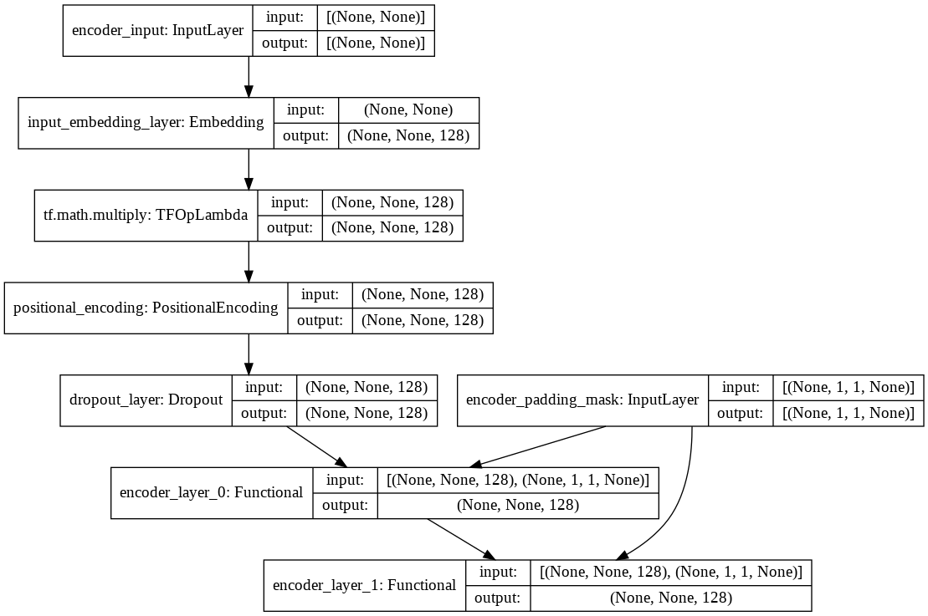
Figure 7. Encoder Layers
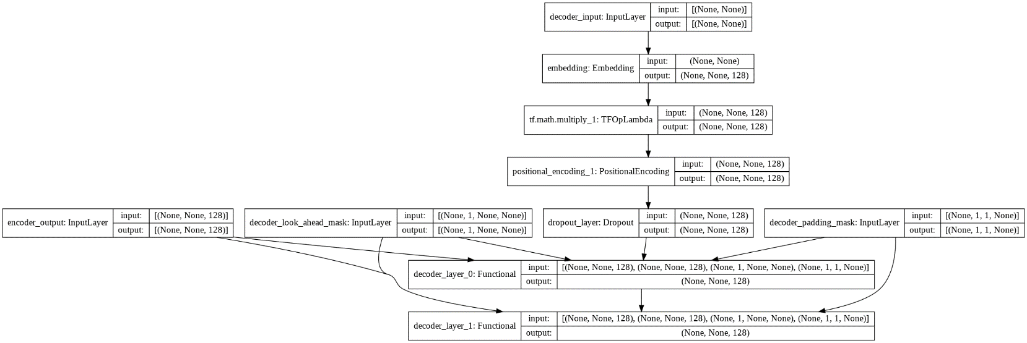
Figure 8. Decoder Layers
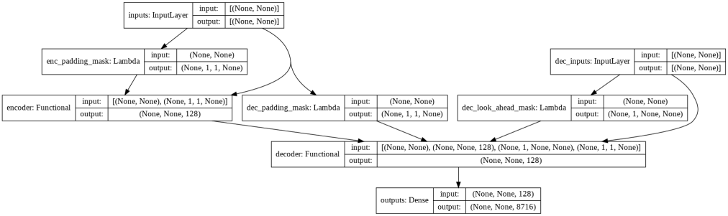
Figure 9. Complete Model Architecture
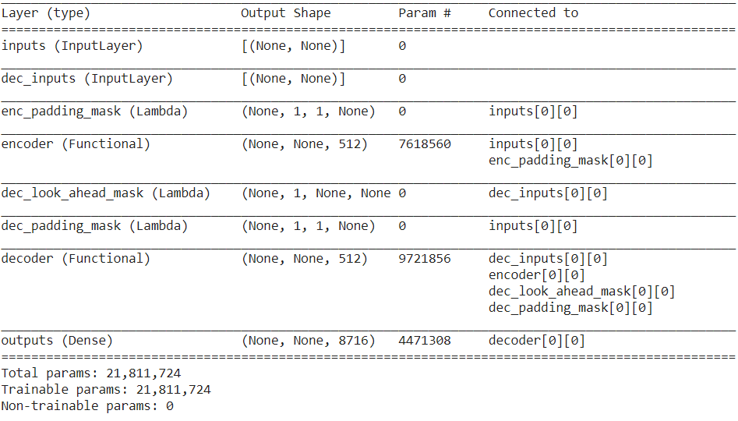
Figure 10. Final Keras Model Summary

      - Sentiment analysis
Textblob is a Python package that includes built-in classes for analyzing the sentiment of sentences. Specifically, TextBlob examines each user input and categorises it as positive, neutral, or negative. It produces the following values for any English sentence: -1, 0, 1.
-1: the input is negative
0: the input is neutral
1: the input is positive
In the proposed system, a sentiment score is generated for each user input. The sentiment scores for all inputs are added at the end of the session to generate a final score. The final score of the user is used to determine whether or not to take the PHQ-9 depression assessment. If the final score is less than 0, the user is required to give the evaluation. Otherwise, the user has the option of giving or not giving the assessment. We have tried the sentiment score for the English language; however same for the Hindi language is kept as future work as this sentiment analysis method only works for English inputs.

    - Server Configuration and Virtual Avatar
In this section, the complete technical configuration is discussed. It is divided into two parts; server configuration and virtual avatar configuration. Each part is explained in the following sections.

      - Server Configuration
Python is used to run the chatbot and sentiment analysis, while Android is used for the user interface (java). A flask server is created to allow these two to communicate effectively. The Retrofit Library is used by the Android application to send a request to the server. The user's query is included in this request. For the request, JSON is employed as an intermediary format. The flask server extracts the user's request and sends it to the chatbot system. The chatbot system then predicts the response while also calculating the sentiment score. This data is returned to Android by the Flask server. Figure 11 shows server to application connection architecture.
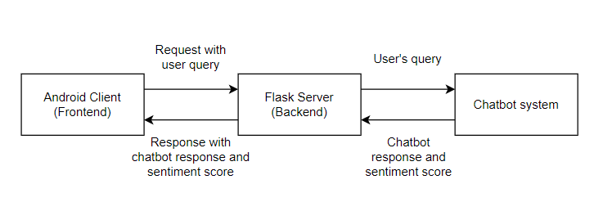
Figure 11. Server to application connection architecture
      - Virtual Avatar Configuration
The user can utilize the messaging interface or the virtual avatar to communicate with the chatbot. There are a total of 6 avatars as follows:
1) Male
2) Female
3) Child Male
4) Child Female
5) Old Male
6) Old Female
Figure 12 shows communication interface along with sample virtual avatar.
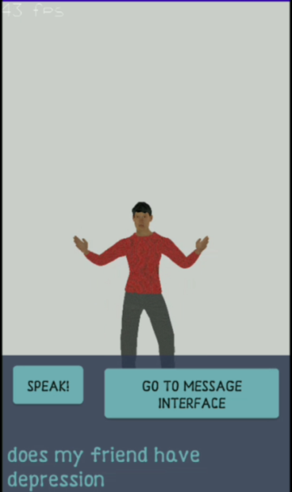
Figure 12. Communication Interface along with Sample Virtual Avatar
The OpenGL ES-based rendering pipeline is used to render these avatars on the screen. Models, animations, and rigs are all saved in Collada format. MakeHuman, an open-source software, was used to create these models. The essential animations were acquired from the Mixamo website. Blender was used to create these models and setups, and animations are baked in a specific order. Each avatar has three animations, as given below:
1) Idle
2) Talking
3) Waving
The talking animation is activated when the chatbot generates an output. Otherwise, the avatar's idle animation continues to loop. Callbacks are used to transition between these animations. For interactivity, the virtual avatar interface uses void input and output. The user query is entered via the Google Speech-To-Text API, and the flask server receives this query. The user receives the response from the flask server via Text-To-Speech API of Android. The Text-To-Speech API callbacks are used to trigger the talking and idle animations for the avatar.
The user's voice is captured using the Speech-To-Text service using the speech-to-text API of Google. The user's voice inquiry is decoded and returned in text format using this API. The user's voice is captured using the Speech-To-Text service using the Speech-To-Text API of Google. The user's voice inquiry is decoded and returned in text format using this API. This text is then sent to the server. The server responds with a textual answer. The response is converted to voice using the Text-To-Speech service. The voice is the standard one set by the user. Thus, the answer is delivered using voice, and the talking animation is toggled simultaneously.

- Results And Discussion
Based on the progression of the dataset, the chatbot was trained in three different forms. There were 1330 rows in the initial dataset (pairs of questions and their respective answers). These were not processed, resulting in a training accuracy of around 33%. The training accuracy of a model refers to how successfully it has been trained. The accuracy of the dataset increased to 58% after pre-processing. Table II contains all of the evolution results,
TABLE II
DATASET AND MODEL EVOLUTION
Sr. No. | Number of rows in dataset | Modifications performed | Training accuracy (%)
1 | 1330 | Initial unprocessed dataset | 33
2 | 1330 | Processed the answers and question by limiting their length | 58
3 | 2300 | Appended some more new questions | 61
4 | 3500 | Used data augmentation | 68
5 | 6907 | Added Hindi dataset | 66
The model is better trained on large amounts of high-quality processed data, as seen in Table III. Table III shows the statistics of the model. For questions with a structure similar to that of the datasets, the chatbot performs quite well. However, it has been noticed that in some cases, it produces incorrect responses. As a result, it still needs more data to completely comprehend user queries and improve the natural language processing of the chatbot.
TABLE III
MODEL STATISTICS FOR LATEST VERSION
Sr. No. | Parameters | Value
1 | Total trainable parameters | 21,811,724
2 | Training accuracy reached | 0.66
3 | Trained on | Google Collab with GPUs
4 | Time taken per epoch | 6 sec approx..
5 | Total time taken for training | 15 minutes approx..
6 | Total Epochs used for training | 125
7 | Loss at the beginning | 6.059
8 | Loss at the end | 3.0447
The training graph per epoch for accuracy and loss is shown in Figure 13.
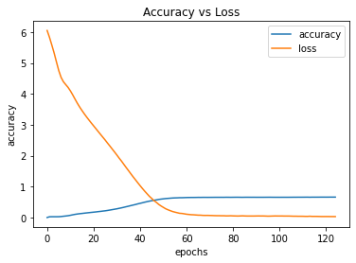
Figure 13. Accuracy and loss against epochs
- Conclusion
As a result of the COVID-19 lockdown, there has been an increase in mental stress and other linked disorders. The authors developed a chatbot system for mental health aid to address this scenario. The suggested work critically examines the NLP tasks for use in COVID-19 and mental health chatbot systems. To complete the NLP tasks, the authors used sequence-to-sequence transformers. The best algorithm is picked depending on the chatbot's functionality and the domain where the services will be provided. Along with algorithms, the dataset is a key aspect for chatbot systems. The data was gathered from reliable sources and covers the majority of user requests. The above-mentioned technique and dataset were utilized to achieve a training accuracy of 66%.
References

[1] He, F., Deng, Y., & Li, W. (2020). Coronavirus disease 2019: What we know? Journal of Medical Virology, 92(7), 719–725. https://doi.org/10.1002/jmv.25766
[2] Dawel, A., Shou, Y., Smithson, M., Cherbuin, N., Banfield, M., Calear, A. L., Farrer, L. M., Gray, D., Gulliver, A., Housen, T., McCallum, S. M., Morse, A. R., Murray, K., Newman, E., Rodney Harris, R. M., & Batterham, P. J. (2020). The Effect of COVID-19 on Mental Health and Wellbeing in a Representative Sample of Australian Adults. Frontiers in Psychiatry, 11. https://doi.org/10.3389/fpsyt.2020.579985
[3] Liu, J. J., Bao, Y., Huang, X., Shi, J., & Lu, L. (2020). Mental health considerations for children quarantined because of COVID-19. The Lancet Child & Adolescent Health, 4(5), 347–349. https://doi.org/10.1016/s2352-4642(20)30096-1
[4] Grover, S., Sahoo, S., Mehra, A., Avasthi, A., Tripathi, A., Subramanyan, A., Pattojoshi, A., Rao, G., Saha, G., Mishra, K., Chakraborty, K., Rao, N., Vaishnav, M., Singh, O., Dalal, P., Chadda, R., Gupta, R., Gautam, S., Sarkar, S., . . . Janardran Reddy, Y. (2020). Psychological impact of COVID-19 lockdown: An online survey from India. Indian Journal of Psychiatry, 62(4), 354. https://doi.org/10.4103/psychiatry.indianjpsychiatry_427_20
[5] Bhirud, N., Tataale, S., Randive, S., & Nahar, S. (2019). A Literature Review On Chatbots In Healthcare Domain. International Journal of Scientific & Technology Research, 8(7), 225-231.
[6] Kumar, A., & Nayar, K. R. (2020). COVID 19 and its mental health consequences. Journal of Mental Health, 30(1), 1–2. https://doi.org/10.1080/09638237.2020.1757052
[7] Chaturvedi, A., Srivastava, S., Rai, A., & Cheema, A. (2020). A Hybrid Approach to Develop and Integrate Chatbot in Health Informatics Systems. Proceedings of the 13th International Joint Conference on Biomedical Engineering Systems and Technologies. Published. https://doi.org/10.5220/0009188007740781.
[8] Gabrielli, S., Rizzi, S., Bassi, G., Carbone, S., Maimone, R., Marchesoni, M., & Forti, S. (2021). Engagement and Effectiveness of a Healthy-Coping Intervention via Chatbot for University Students During the COVID-19 Pandemic: Mixed Methods Proof-of-Concept Study. JMIR MHealth and UHealth, 9(5), e27965. https://doi.org/10.2196/27965
[9] Ferreira, Thiago & Marcolino, Milena & Oliveira, Isaias & Reis, Zilma & Pagano, Adriana & Prates, Raquel & Meira Jr, Wagner & Ribeiro, Antonio Luiz. (2020). Ana a brazilian chatbot assistant about covid
[10] Cameron, G., Cameron, D. M., Megaw, G., Bond, R. B., Mulvenna, M., O’Neill, S. B., Armour, C., & McTear, M. (2017). Towards a chatbot for digital counselling. BCS Learning and Development. Published. https://doi.org/10.14236/ewic/hci2017.24
[11] Ouerhani, N., Maalel, A., & Ben Ghézela, H. (2019). SPeCECA: a smart pervasive chatbot for emergency case assistance based on cloud computing. Cluster Computing, 23(4), 2471–2482. https://doi.org/10.1007/s10586-019-03020-1
[12] Ni, L., Lu, C., Liu, N., & Liu, J. (2017). MANDY: Towards a Smart Primary Care Chatbot Application. Communications in Computer and Information Science, 38–52. https://doi.org/10.1007/978-981-10-6989-5_4
[13] Chung, K., & Park, R. C. (2018). Chatbot-based heathcare service with a knowledge base for cloud computing. Cluster Computing, 22(S1), 1925–1937. https://doi.org/10.1007/s10586-018-2334-5
[14] Grové, C. (2021). Co-developing a Mental Health and Wellbeing Chatbot With and for Young People. Frontiers in Psychiatry, 11. https://doi.org/10.3389/fpsyt.2020.606041.
[15] Park, & Jong, J. (2018). A Development of Chatbot for Emotional Stress Recognition and Management using NLP. The Korean Institute of Electrical Engineers. Published. https://doi.org/10.5370/KIEE.2018.67.7.954
[16] Amato, F., Marrone, S., Moscato, V., Piantadosi, G., Picariello, A., & Sansone, C. (2017). Chatbots Meet eHealth: Automatizing Healthcare. WAIAH@AI*IA.
[17] Judson, T. J., Odisho, A. Y., Young, J. J., Bigazzi, O., Steuer, D., Gonzales, R., & Neinstein, A. B. (2020). Implementation of a digital chatbot to screen health system employees during the COVID-19 pandemic. Journal of the American Medical Informatics Association, 27(9), 1450–1455. https://doi.org/10.1093/jamia/ocaa130
[18] Ouerhani, N., Maalel, A., Ghézala, H. B., & Chouri, S. (2020). Smart Ubiquitous Chatbot for COVID-19 Assistance with Deep learning Sentiment Analysis Model during and after quarantine. Research Square. Published. https://doi.org/10.21203/rs.3.rs-33343/v1
[19] Rodsawang C, Thongkliang P, Intawong T, Sonong A, Thitiwatthana Y, Chottanapund S. Designing a competent chatbot to counter the COVID-19 pandemic and empower risk communication in an emergency response system. OSIR. 2020 Jun; 13(2):71-77.
[20] Battineni, G., Chintalapudi, N., & Amenta, F. (2020, June). AI chatbot design during an epidemic like the novel coronavirus. In Healthcare (Vol. 8, No. 2, p. 154). Multidisciplinary Digital Publishing Institute.
[21] Bharti, U., Bajaj, D., Batra, H., Lalit, S., Lalit, S., & Gangwani, A. (2020). Medbot: Conversational Artificial Intelligence Powered Chatbot for Delivering Tele-Health after COVID-19. 2020 5th International Conference on Communication and Electronics Systems (ICCES). Published. https://doi.org/10.1109/icces48766.2020.9137944.
[22] Sancheti, R., Upare, S., Bhirud, N., & Tatale, S. (2020). Adaptive Machine Learning Chatbot for Code-Mix Language (English and Hindi). International Journal of Recent Technology and Engineering (IJRTE), 8(5), 3566-3572.
[23] Comendador, B. E. V., Francisco, B. M. B., Medenilla, J. S., Nacion, S. M. T., & Serac, T. B. E. (2015). Pharmabot: A Pediatric Generic Medicine Consultant Chatbot. Journal of Automation and Control Engineering, 3(2), 137–140. https://doi.org/10.12720/joace.3.2.137-140
[24] Menni, C., Valdes, A. M., Freidin, M. B., Sudre, C. H., Nguyen, L. H., Drew, D. A., Ganesh, S., Varsavsky, T., Cardoso, M. J., El-Sayed Moustafa, J. S., Visconti, A., Hysi, P., Bowyer, R. C. E., Mangino, M., Falchi, M., Wolf, J., Ourselin, S., Chan, A. T., Steves, C. J., & Spector, T. D. (2020). Real-time tracking of self-reported symptoms to predict potential COVID-19. Nature Medicine, 26(7), 1037–1040. https://doi.org/10.1038/s41591-020-0916-2
[25]. Avasthi, A., Varma, S. C., Kulhara, P., Nehra, R., Grover, S., & Sharma, S. (2008). Diagnosis of common mental disorders by using PRIME-MD Patient Health Questionnaire. The Indian journal of medical research, 127(2), 159–164.
[26] Dataset for COVID - 19 Questionnaire will be available on - https://github.com/deepset-ai/COVID-QA.
[27] Dataset for Mental Health Questionnaire will be available on - https://github.com/nbertagnolli/counsel-chat/tree/master/data

